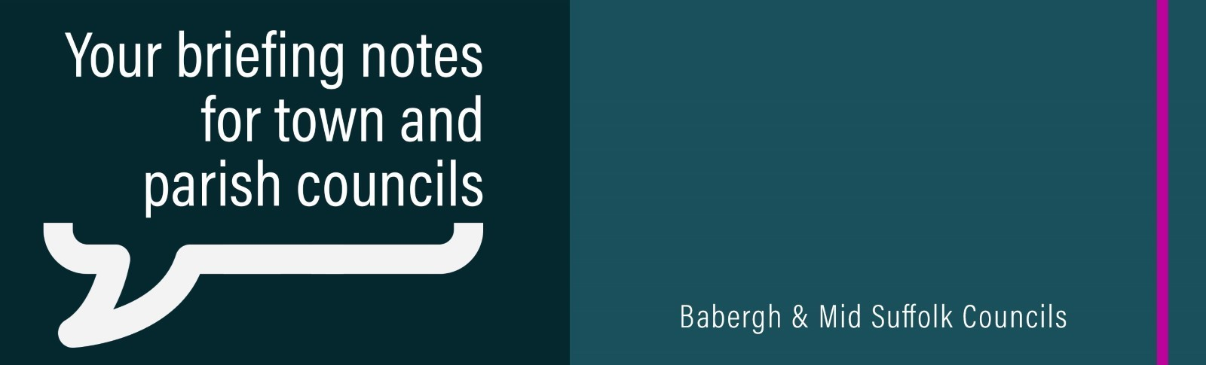
Mid Suffolk District Council published its second annual State of the District report this month
Drawing on a range of open-source data published at district level and the Council’s own resident survey, the report provides an overview of data that highlights many of the strengths within the district alongside some of the key challenges that the Council and its partners are seeking to address.
Councils first in country to clear the way for listed building energy upgrades
Babergh and Mid Suffolk District Councils will clear the way for thousands of listed building owners to make sensitive energy efficiency upgrades – in a new approach which is the first of its kind in the country.
Hundreds to get £50 off council tax bills as Mid Suffolk agrees new cost-of-living support
Mid Suffolk District Council has agreed new cost-of-living support for residents - including cuts to hundreds of council tax bills, and stepping in to replace a Government fund which ends in October.
Additional funding approved to allow vulnerable residents to stay in their own homes
Babergh and Mid Suffolk District Councils have this week agreed to increase grants to carry out home adaptions for some of their most vulnerable residents.
Planning go ahead for green tenants at Gateway 14
Planning consent has been granted for two buildings at Gateway 14, Stowmarket, both occupied by manufacturers of eco-friendly construction materials.
Library extension and play facilities boosted by £600k fund
A £538,000 contribution to a library refurbishment is one of the projects to benefit from monies collected from developers in Mid Suffolk.
Council house improvements at risk due to ‘broken’ funding system, authority warns
Mid Suffolk District Council has warned progress on improving its council homes is under threat due to serious challenges caused by a ‘broken’ national funding model.
Community Governance Reviews in Mid Suffolk – next steps
Following consultation with residents, Mid Suffolk District Council voted earlier this year to accept the recommendations of its Community Governance Working Group and not to change the administrative boundary between Onehouse Parish Council and Stowmarket Town Council.

Initiative to tackle inequality reaches 100,000 participation and meals milestone
An initiative, backed by Babergh and Mid Suffolk District Councils, designed to encourage young people to exercise and enjoy outdoor activities has reached an important milestone.
New brand launched to help Suffolk Coast get Wildlife Wise
A project working with local residents and visitors to prevent disturbance and damage to wildlife and habitats along the Suffolk Coast has been given a fresh new look.

