Footpaths and Rights of Way

Maintenance and Seasonal Clearance
The legal position is that Suffolk County Council is responsible for clearance of seasonal growth and the repair of structures and bridges. The county council uses a tractor mounted mower to cut all the vehicle accessible paths. Since the 1990s the parish council has received a grant from the county council to clear seasonal growth by hand using a strimmer on those footpaths not accessible to a tractor mower, to provide wooden steps on steep sections of footpaths and to maintain way marker plates to show the correct route of rights of way. In 2022 the parish council decided to relinquish this work and leave it to the county council. This year the parish council has received a number of complaints about overgrown footpaths. The County Council seems unlikely to ever cut those parts of the footpaths not accessible to a tractor mower, and certainly not in a timely manner. Therefore, the parish council is considering taking back responsibility for cutting those hard to access parts of the footpath network. In order to clear seasonal growth a number of volunteers would be required or a contractor employed. Most of the routes needing hand cutting are around the village centre. If you would like to volunteer to help clear paths in May then please let the clerk know.

Kissing Gates

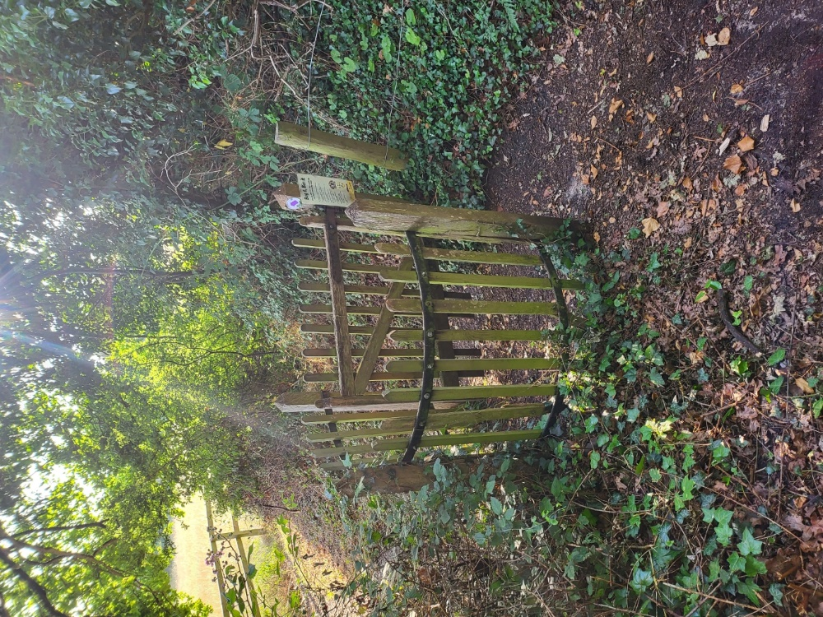
Kissing Gates are a traditional way of allowing people to walk a footpath whilst preventing livestock from passing through. The one in the picture is at the western end of Broomhill. There are also three more at the entrances to the churchyard. These are residual features left over from the days when sheep grazed the churchyard and cattle roamed on Broomhill. In 1985 the remnants of the kissing gate at the eastern end of Broomhill were dismantled. There is no prospect of livestock being grazed in the churchyard or Broomhill in the foreseeable future and therefore the kissing gates are redundant for their original purpose. They are a historic feature and have character. The use of kissing gates and styles are discouraged now as they do not allow for disabled and pushchair access along paths. The gate shown in the picture needs repair work as one of the posts has rotted. The parish council wants to know whether to repair these gates as they deteriorate or simply remove them. Please email you thoughts to the clerk.

