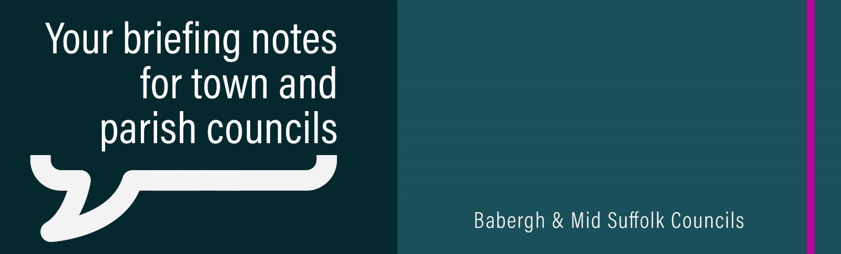

Council tax freeze agreed for Mid Suffolk
Mid Suffolk District Council has bucked a nationwide trend by agreeing to freeze its element of council tax for the upcoming financial year – helping residents to navigate the cost-of-living crisis while continuing investment in priority areas to improve quality of life in the district.
Energy infrastructure ‘must be coordinated’ to minimise impact on Mid Suffolk communities
Rising demand for energy developments and connections to the National Grid in Mid Suffolk must be coordinated to minimise the harm on local communities and the environment, it has been warned.
£150k boost to community projects across Babergh and Mid Suffolk
Funding towards a new football club stand and play area improvements are among 21 grants to support community groups and organisations in Babergh and Mid Suffolk.
Mid Suffolk leader named co-president of national cross-party climate network
Mid Suffolk District Council leader, Cllr Andy Mellen, has been announced as the new co-president of UK100, the national network committed to tackling the climate crisis at local level.
National recognition for Babergh and Mid Suffolk District Councils’ building control team
Babergh and Mid Suffolk District Councils’ building control team has been named as the best in the business.
Council to consider funding design of Residents’ Parking Zone in Stowmarket
Mid Suffolk District Council is set to consider plans to help tackle residents’ parking issues in Stowmarket by investing in the next stage of a possible residents’ parking zone (RPZ).
Wildlife Wise announces new grant project support
A new small grant scheme has been announced by Wildlife Wise, supporting projects that aim to prevent recreational disturbance and damage to Suffolk's coast and its important wildlife and habitats.
Ipswich to Cambridge Community Rail Partnership gets underway
The new Ipswich to Cambridge Community Rail Partnership (CRP), backed by Mid Suffolk District Council, is up and running and preparing for its first full year of operation.
Government launches public consultation on Suffolk and Norfolk devolution
The Government has launched a public consultation on proposals to create a Mayoral Combined County Authority across Norfolk and Suffolk.
Support for our residents – in a way that suits them
From Monday 24 February, we are extending our opening hours at our customer access point in Stowmarket – offering face-to-face support for residents, five days a week.
Covid-19 day of reflection
On Sunday 9 March 2025, the UK will recognise a Covid-19 Day of Reflection. If your community wishes to take part, you can find a full list of resources about the day of reflection on our website.
New tenant handbook
Housing Services have launched a new tenant handbook, providing information about tenants’ rights and responsibilities, as well as setting out what the council’s responsibilities are as their landlord.

