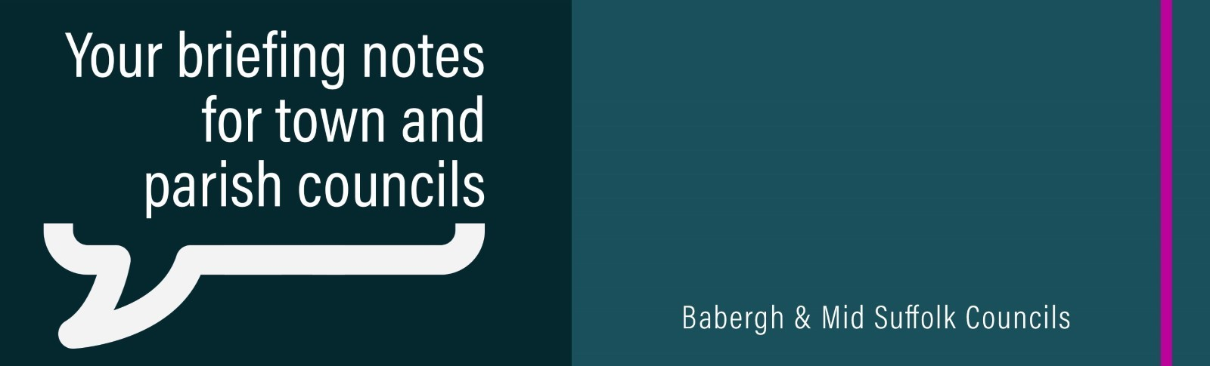

April 2024

Mid Suffolk named UK Council of the Year at prestigious awards ceremony
Babergh and Mid Suffolk District Councils have taken the top honour at a prestigious local government awards ceremony.

Upcoming elections and referendums
The next election within our district is on Thursday 2 May, and deadlines to register to vote, apply for a postal vote and get appropriate voter ID are fast approaching. More details about this election, including relevant links and information about all deadlines can be found on the council’s website.

£3.8m pledged for energy efficient council homes
Work to make council homes warmer and bring down energy bills for tenants across Babergh and Mid Suffolk received a £1.6m boost in government funding during March. The funding is to be added to the £2.25m already committed by the councils to install energy saving measures in social housing, taking the total investment pledged for retrofitting and decarbonising to £3.85m across both districts.

Councils pledge further help to prevent homelessness
More than 1,500 households at risk of homelessness have been helped to keep a roof over their heads by Babergh and Mid Suffolk District Councils since 2019, with both councils pledging further support as part of their joint homelessness reduction and rough sleeping strategy.

Council wants clarity from developer over major solar farm proposal
Mid Suffolk District Council says a developer must provide more clarity around its plan for a ‘nationally significant’ new solar farm in the district.

Grid reinforcement can’t come at any environmental cost
Babergh and Mid Suffolk District Councils have formally objected to National Grid’s plans for more electricity pylons between Bramford and Twinstead – saying the impact on the countryside is too great.

Cash injection for local community projects
More than £510,000 is set to be reinvested into Babergh and Mid Suffolk communities thanks to funding collected from developers.

Planning application submitted for new distribution hub at Gateway 14
A planning application has been submitted to Mid Suffolk District Council to construct a 44,000 sq ft distribution hub at Gateway 14, Stowmarket, for a major supplier of eco-friendly construction materials.

Cancer conman caught as part of councils’ crackdown
A former tenant who pretended to have cancer to try to con his way up the council housing list is amongst the fraud and corruption tackled recently by Babergh and Mid Suffolk District Councils, according to an annual report.

Mid Suffolk’s community spirit inspires ‘Musical Memories’
Months of musical workshops came to crescendo in Stowmarket during March, after a long-running partnership between Mid Suffolk District Council, national charity Orchestras Live and a renowned professional orchestra.

Fun for families over the Easter holidays
There is a wide range of activities on offer for children during the Easter holidays in Babergh and Mid Suffolk.

Works underway to create Changing Places facilities in Stradbroke
Works to create fully accessible toilet facilities have started at a council-run leisure centre, as part of work across Babergh and Mid Suffolk to improve facilities for those with additional needs.

New Suffolk campaign urges drivers to switch their engines off
A new campaign urging Suffolk’s drivers to switch off their engines when parked is running across the district.

